**The Guild of Freemen of the City of London**

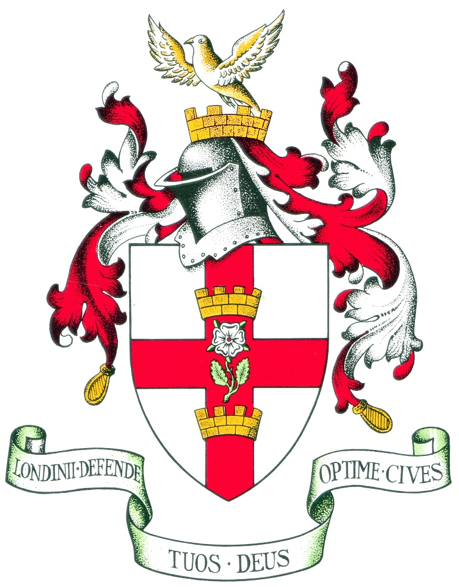

Programme of Events

2025

## Master

## ADRIAN WADDINGHAM CBE

**The Programme of Events for the Master’s year 2025**

The first rules of the Guild in 1908 were commendably brief, simply commanding the Court to arrange social events. Recent Masters have kept us busy doing interesting things and I shall endeavour to do the same in 2025.

There will be two Guild holidays, both on home territory so no need for visas or airports. First to Norfolk in April staying near Sheringham. We will ogle more than 200 working military vehicles at former Lord Mayor of London, Sir Michael Savory’s, personal tank collection. A private tour of Sandringham House follows, then dinner on the estate. On day two visit at one of the finest Palladian houses in England, Holkham Hall, home of the Earl of Leicester.

In late September we visit my home ground in the Southern Lake District staying four nights at the beautiful Lakeside Hotel, adjacent to the steamer jetty at the south end of Lake Windermere. The treats in store include England’s best topiary gardens at Levens Hall; English Heritage’s first ever site, a working bobbin Mill; sailing by steamer to the impressive new Jetty Museum and its collection of historic boats and on to Blackwell, one of England’s most stunning Arts & Craft houses; we will visit Wordsworth in his museum at Dove Cottage in Grasmere.

The Guild’s first outing of 2025 is a visit to inspect the ongoing restoration work at St Bart’s Great Hall on 28th January followed by a Smithfield pub supper. February sees us visiting St Bride’s in Fleet Street and the Print Room, and the Crick Museum at King’s Cross. Details of all events are set out in the following programme.

My wife Angela will lead us on guided walks around Kings Cross and Battersea. A highlight will be a visit to my alma mater, the impressive Victorian Royal Holloway College near Egham and its renowned Picture Gallery. In July we shall have a night at the Opera in Holland Park, La Traviata with a picnic hamper.

Guild member Andrew Johnson will once again present one of his popular virtual talks, and we shall attend City events including the United Guilds Service and the Sheep Drive across London Bridge.

We shall not go hungry, lunching on the best of English fare at Forman & Son’s smoked salmon factory at Stratford, and putting ourselves in the hands of trainee chefs at the Westminster Catering College in Vincent Square. We will dine at Barber-Surgeons’ Hall, Haberdashers’ Hall, and Trinity House, plus a lunch-time feast at Mercers’ Hall - which I hope will appeal to those members who find it difficult to join evening events. At one of our dinners there will be an auction to raise funds for the Guild’s charity.

I look forward to seeing you at these events during the year.

**Adrian Waddingham**

We continue to offer some virtual events as well as some of our regular activities such as the Sheep Drive, City Walks, visits to the College of Arms and of course the Annual Banquet. As usual photographs of most events will be available to view on the website. Contact the Assistant Clerk if you wish for higher resolution copies. **NB.** **If you or your guests do not wish to be photographed or have images published, you must let the photographer and Clerk know on each occasion.**

The Guild offers members opportunities to attend City Events, either with the Guild or as individuals. City Events are at the back of the programme. Not all information is known at the time of printing, but you can check the Guild’s website for more up to date information.

This year, the main City events are the Lord Mayor’s Big Curry Lunch on 10th April and the Sheep Drive on 28th September and the Lord Mayor’s Show on 8th November. In addition, the Guild has thirteen tickets to the United Guild's Service on 28th March at St Paul's Cathedral for members and guests. The service is free of charge; please apply in the usual way.

All events are bookable online at the Guild’s website [link](http://www.guild-freemen-london.co.uk) but please contact the Assistant Clerk at [admin@guild-freemen-london.co.uk](mailto:admin@guild-freemen-london.co.uk) if you have any difficulty. **Unless an event shows as full on the website, please do apply after the allocation date has passed. We allocate early to allow you to plan your diary. *Should an event be oversubscribed, then it will go to ballot.***

If you have only recently moved to email, please advise us of your email address by emailing [admin@guild-freemen-london.co.uk](mailto:admin@guild-freemen-london.co.uk) as this will enable you to receive our 4-6 weekly newsletter.

All events are correct at time of publication but are subject to change without notice. Notes on applying for events are at the end of this document.

The website will show any additions to the programme and information about events and availability will be sent in the Newsletter.

**Personal Health and Travel Insurance**

Please note that members and guests are responsible for arranging their own health and travel insurance for all holidays, whether in the UK or overseas. Please ensure you have insurance as soon as you have booked in case you need to cancel.

The Guild cannot accept liability or refund payments made if anyone cancels a booking after the stated latest cancellation date notified in the allocation letter or email.

**Programme 2025**

|  |  |  |  |
| --- | --- | --- | --- |
| **Thursday 23rd January**  **6:15pm – 7:00pm** | **Event No. 1 and 2** | | **Installation of the Master and Wardens and Dinner**  **Dress: Jacket & Tie for the Installation and Black tie for dinner** |
| The Installation Ceremony of the Guild of Freemen of the City of London will be held at Tallow Chandlers' Hall, 4 Dowgate Hill, in the City of London, on the 23rd of January 2025. The nearest underground station is Cannon Street and Bank and Mansion House are also nearby.   The ceremony will begin promptly at 6.15pm, when the Master, Wardens and Court Assistants will process into the Installation. Please arrive by 6pm.   During the ceremony the Master, Lisa Rutter, will install the new Master, Adrian Waddingham CBE who will then install his wardens:  Stephen Osborne, Alistair Mitchelhill and Lady Lauriston. He will then address Lisa as the Immediate Past Master. The ceremony will last around 20 minutes, after which everyone is invited to join the Master, Wardens and Court Assistants for a reception in the Parlour.   The Master will bid those who are not staying for dinner farewell at about 7pm, before he, and those who are staying for dinner, make their way into the Hall.  **There is no charge to attend the Installation, however for catering purposes and to ensure that sufficient seating is available, please do let us know if you will be attending no later than Wednesday 15th January.** | | | |
| **Tickets for the dinner: £140 per person** | | *Ticket Allocation Date: from 9th January 2025* | |

|  |  |  |  |
| --- | --- | --- | --- |
| **Tuesday 28th January**  **4pm – 9pm** | **Event No. 3** | | **Private tour of the Great Hall at Barts followed by a pub supper**  **Dress: Smart / casual** |
| The Great Hall at St Bartholomew’s is Grade I listed and is the oldest hospital still operating on its original site. The Hall was once used as the meeting place of the Governors and medical students sat their exams in the Hall until the 1990’s. Since August 2024 a conservation project has been undertaken to protect and preserve the amazing ceiling, a masterpiece of Jean Baptiste St Michele, the famous portrait of Henry VII and the hospital’s patron Saint, Bartholomew and to upgrade the heating and other systems. The conservation project will not be completed until next summer, so this is the opportunity for Guild members to see *conservation in action*. For that reason, this visit is not for those with mobility issues as it includes climbing on scaffold blocks to view the ceiling.  The tour will begin at 4pm and last for roughly two hours, after which we will enjoy a two-course supper at a nearby pub. | | | |
| **Tickets: £85 per person** | | *Ticket Allocation Date: 14/1/2025* | |

|  |  |  |  |
| --- | --- | --- | --- |
| **Tuesday 11th February**  **12:30am – 3:30pm** | **Event No. 4** | | **Lunch at Cote and a private tour of the St Bride Foundation Print Room**  **Dress: Smart / Casual** |
| We will meet at Cote on Ludgate Hill, near St Paul’s at 12 noon to enjoy a three-course lunch with wine, before taking a short walk to the St Bride Foundation. In the heart of this Grade II Victorian listed building is an exceptional and rare archive relating to all matters printing, publishing and graphic design. | | | |
| **Tickets £85 per person** | | *Ticket Allocation Date: 14/1/2025* | |

|  |  |  |  |
| --- | --- | --- | --- |
| **Tuesday 25th February**  **11am – 3.30pm** | **Event No. 5** | | **Tour of a Private Jade collection followed by lunch in Chelsea**  **Dress: Smart / casual** |
| Join the Master for a privileged visit to a world-renowned collection of 18th century jades, the Woolf collection. Our guide who is the curator of the Chinese jade also works at the British Museum and is an equally world-renowned jade expert.  After the tour we will have lunch at the Botanist Sloane Square. | | | |
| **Tickets: £95 per person** | | *Ticket Allocation Date: 27/1/2025* | |

|  |  |  |  |
| --- | --- | --- | --- |
| **Thursday 6th March**  **6pm – 9pm** | **Event No. 6** | | **Visit and Buffet Supper – College of Arms**  **Dress: Suit/Jacket & Tie** |
| This ever-popular annual event comprises a fascinating talk and tour of the College of Arms by William Hunt the research assistant to John Petrie, Windsor Herald, who will give members the opportunity to view some of the spectacular examples of the College's work over the past 800 years. The College of Arms is the official heraldic authority for England, Wales, Northern Ireland and much of the Commonwealth including Australia and New Zealand.  As well as being responsible for the granting of new coats of arms, the College maintains registers of arms, pedigrees, genealogies, Royal Licences, changes of name, and flags. We will hear about the Heralds' ceremonial duties and their unique place in our history.  The tour will conclude with a substantial buffet supper with wine. | | | |
| **Tickets: £75** | | *Ticket Allocation Date:25/02/2025* | |

|  |  |  |  |
| --- | --- | --- | --- |
| **Tuesday 11th March**  **6:30pm start** | **Event No. 7** | | **Virtual talk by Andrew Johnson** |
| **Pirates, Privateers, Buccaneers and Corsairs** - Join Andrew Johnson to look at the heyday of the lawlessness on the high seas - some of it state sponsored.  Andrew is a Guild member, a Liveryman of the Worshipful Company of Joiners and Ceilers, an experienced international chief executive and a respected keynote speaker. | | | |
| **The talk is free of charge however donations to the Guild Charity are strongly encouraged.** | | *Ticket Allocation Date: on application* | |

|  |  |  |  |
| --- | --- | --- | --- |
| **Thursday 26th March**  **6:30pm – 10:30pm** | **Event No. 8** | | **Dinner at Barber Surgeons’ Hall**  **Dress: Black Tie** |
| The Worshipful Company of Barbers has had a Hall on the edge of the City, in the area of the northwest corner of the Roman Fort of London, since the 1440s. The first hall, built on the present site in 1441, burned down in the Great Fire of London in 1666. The hall was rebuilt and lost again to the Luftwaffe in 1940, along with the rest of the old Barbican.  The current Hall opened on the 13th May 1969 by Her Majesty Queen Elizabeth the late Queen’s mother.  The Hall has an amazing array of art and antiques dating back to Tudor times, including a collection of letting bowls and a painting commissioned by Henry VIII by Hans Holbein.  The Master will welcome you to a sparkling reception, which will be followed by a splendid three-course dinner with wine. The evening will conclude with port, toasts and a speech from for Her Honour Judge Wendy Joseph KC (now retired and an author – do read *Unlawful Killings: Life, Love and Murder, Trials at the Old Bailey* if you have not already done so) so an interesting speech is in store.  This event follows our welcoming ceremony for new members, who may wish to continue their celebrations by attending this dinner. | | | |
| **Tickets: £145 per person.** | | *Ticket allocation 18/2/2025 – places are still available*. | |

|  |  |  |  |
| --- | --- | --- | --- |
| **Friday 28th March**  **10:45am – 12:15pm** | **Event No. 9** | | **United Guilds Service at St Paul’s Cathedral**  **Dress: Suit/Jacket & Tie** |
| The Guild has thirteen tickets to the United Guild's Service at St Paul's Cathedral for members and guests. The service is free of charge, and you must be seated by 10.45am.  There is a lunch following the Service, see event 10. | | | |
| **Tickets: The Service is free of Charge.** | | *Ticket Allocation Date: 4/3/2025.* | |

|  |  |  |  |
| --- | --- | --- | --- |
| **Friday 28th March**  **12:30 – 3pm** | **Event No. 10** | | **Lunch at Pewterers’ Hall**  **Dress: Suit /Jacket & Tie** |
| After the Service we are offering Guild members the opportunity to join the Pewterers’ and other Liveries at their Hall. Pewterers’ are offering a pre-lunch reception before a three-course lunch with wines from their own cellar.  Members are welcome to attend the lunch even if you have not been able to attend the Service. | | | |
| **Lunch £100 per person** | | *Ticket Allocation Date: 4/3/2025* | |

|  |  |  |  |
| --- | --- | --- | --- |
| **Sunday 6th April -**  **Tuesday 8th April** | **Event No. 11** | | **Holiday in Norfolk**  **Dress: Smart casual** |
| The Master has arranged a visit to Norfolk. Arriving Sunday evening we will stay at the Pheasant Hotel at Kelling.  On Monday morning we will visit former Lord Mayor Sir Michael Savory’s nearby collection of over 200 military vehicles, the Muckleburgh Military Collection. In the afternoon we will travel by coach to Sandringham House for a private tour and have dinner on the estate.  On Tuesday we will tour Holkham Hall, the home of the Earl of Leicester, taking lunch in their Lady Elizabeth Wing. We will make our way home after the lunch. Lifts will be offered to railway stations for those travelling by train. | | | |
| **Tickets: £600 per person if a couple / two people sharing or £650 for single occupation** | | *Places are allocated*  **Wait list only** | |

|  |  |  |  |
| --- | --- | --- | --- |
| **Thursday 10th April**  **12pm – 3pm** | **Event No. 12** | | **The Lord Mayor’s Big Curry Lunch**  **Dress: Suit/Jacket & Tie** |
| The Master will be supporting The Lord Mayor’s Big Curry Lunch which will be held at London’s Guildhall. The lunch supports members of His Majesty’s Armed Forces and Veterans who have served in Iraq and Afghanistan through the national Service Charities: ABF The Soldiers’ Charity, the Royal Navy and Royal Marines Charity, and the Royal Airforce Benevolent Fund. It focusses on individual pain management programmes and on preparation and training for civilian employment. The lunch is hosted by the Lord Mayor, the Lady Mayoress, the Sheriffs and their consorts.  Tickets include unlimited curry, beer and wine in the Great Hall. The Guild has a number of tickets which give us access to the reception area of the Livery Hall and Crypts with a complimentary glass of champagne.  Some Livery Companies have their wares for sale in the South Ambulatory of Guildhall (Easter presents perhaps).  If you are not successful in securing one of the champagne tickets (we have 20 available) you will be offered standard tickets (if still available), which do not include champagne or access to the reception area.  Applications made will be firm and non-refundable unless we can sell tickets to other members, and the allocation of tickets is in the order of application. | | | |
| **Tickets: £110per person** | | *Ticket allocation – 4/3/2025* | |

|  |  |  |  |
| --- | --- | --- | --- |
| **Monday 28th April**  **2pm – 4/5pm** | **Event No. 13** | | **A walk around Vauxhall and tea**  **Dress: for the weather** |
| **Angela Waddingham** will lead a walk around the Vauxhall / Battersea area. We will meet at Vauxhall tube station at 2pm.  This guided walk will include passing by the US Embassy, houseboats and will conclude at Battersea Power Station and will mean being on your feet for about 2 hours, so do wear comfortable walking shoes. After the walk there is the option for the group to have tea together at personal cost. | | | |
| **Tickets: The walk is free of charge** however, a donation to the Guild charity is appreciated. | | *Ticket Allocation Date: 5/3/2025* | |

|  |  |  |  |
| --- | --- | --- | --- |
| **Wednesday 7th May**  **11am – 3pm approx.** | **Event No. 14** | | **Guided tour of the Crick Institute**  **with a guided walk and pub lunch** |
| The Francis Crick Institute is a biomedical research centre in London, which was established in 2010 and opened in 2016. The institute is a partnership between Cancer Research UK, Imperial College London, King's College London, the Medical Research Council, University College London and the Wellcome Trust. This visit is an opportunity to explore what goes on behind the scenes and learn about the Institute’s research.  Angela Waddingham has again volunteered to give guided walking tour from the Institute to our lunch venue which will take about 30-40 minutes. Those who don’t wish to walk may take a taxi or uber to the Lighterman.  Lunch will be three courses with wine in a semi-private area at the very nice Lighterman pub situated in the heart of the redeveloped area of Kings Cross by the canal.  Members who wish to attend the lunch only are welcome to apply to so do however, those who book for the tour will be given priority. | | | |
| **Tickets: £95 per person** | | *Ticket Allocation Date: 5/3/2025* | |

|  |  |  |  |
| --- | --- | --- | --- |
| **Thursday 22nd May**  **11:15am – 3pm** | **Event No. 15** | | **Private tour of the Clock Museum**  **Followed by lunch at a nearby restaurant**  **Dress: smart / casual** |
| The Worshipful Company of Clockmakers holds the oldest world-class collection of clocks, watches and items relating to the art of horology, on permanent display at the Science Museum in London.  The narrative of the Museum's display focuses particularly on the development of clock and watchmaking in London in the period between c.1600 and 1850. It includes pieces by many of the great London makers, including John Fromanteel, Edward East, Daniel Quare and Thomas Tompion. Part of the display also looks at contemporary British clock and watchmaking and includes a number of pieces by the eminent watchmaker Dr George Daniels.  We are privileged that our guided tour of the exhibits will be given by the collections curator and Chairman.  After the visit we will have a three-course lunch with a difference at a nearby Polish restaurant.  Members who wish to attend the lunch only are welcome to apply to so do however, those who book for the tour will be given priority as numbers are limited and for the same reason we are offering this event also on 18th September – event 23. | | | |
| **Tickets: £85 per person** | | *Ticket Allocation Date: 5/3/2025* | |

|  |  |  |  |
| --- | --- | --- | --- |
| **Tuesday 3rd June**  **6pm – about 9:30pm** | **Event No. 16** | | **City Walk 1**  **Dress: Casual** |
| Once again, our City Walks will be led by Peter Tompkins, who is a Past Master of the Wax Chandlers Company. Peter will lead Guild members and their guests on a walk around the square mile looking at some of the new buildings which have emerged in the past 25 years.  Famous for Dr Johnson’s innumerable little lanes and courts, the City is today the site of many groundbreaking modern buildings and skyscrapers.  Our tour will look from outside at a few of those.  After the walk we will a light supper at the Rising Sun in Carter Lane, which is owned by Guild member Shelia Dixon.  As usual, Peter will be hosting the event at no charge but has asked for a donation (suggested as no less than £12 per person) toward the Lord Mayor’s Charity Appeal. **NB**: this event is also available on 23rd July. | | | |
| **Tickets: £65 per person, including supper with a ½ bottle of wine. Please add a donation for the Lord Mayor’s Charity Appeal.** | | *Ticket Allocation Date: 19/3/2025* | |

|  |  |  |  |
| --- | --- | --- | --- |
| **Wednesday 18th June**  **11am (11:30am) – 2pm (2:30pm)** | **Event No. 17** | | **A visit to and lunch at Formans Smokehouse**  **Dress: Smart / casual** |
| The Master is pleased to offer a visit to H Forman & Son (Formans) which is the world’s oldest smoked salmon producer.  We’ll hear from Lance Forman on the history of salmon smoking and of their business, including the impact of the 2012 Olympics. The talk will be followed by a salmon carving demonstration and tour of the factory by Guiness World Record holder – Darren Matson.  After the tour we will have a two-course lunch comprising a smoked salmon starter and gourmet fishcake made by Forman’s award winning chefs. Vegetarian alternatives are available. Lunch includes a glass of English wine or local East End ale. | | | |
| **Tickets: £95 per person** | | *Ticket Allocation 19/03/2025* | |

|  |  |  |  |
| --- | --- | --- | --- |
| **Monday 30th June**  **6:30pm – 10:30m** | **Event No. 18** | | **Black Tie dinner at Haberdashers’ Hall**  **Dress: Black Tie** |
| Home to one of the Great XII Livery Companies, Haberdashers’ first Hall was, like many Livery Halls destroyed by the Great Fire and its second Hall, again like many Livery Halls was lost to WW2 air raid. Their current Hall was opened by her late Majesty the Queen in 2002 following redevelopment by the well-known architect Sir Michael Hopkins and Partners.  The new Hall incorporates a Court Room, a Great (dining) Hall as well as several offices around a Courtyard, which is where, if the weather is clement, we hope to hold the sparkling reception.  In addition to a three-course dinner with appropriate wines the Master is arranging an auction to raise funds for the Guild’s Charity.  This event follows our welcoming ceremony for new members, who may wish to continue their celebrations by attending this dinner. | | | |
| **£140 per person** | | *Ticket Allocation Date: 02/04/2025* | |

|  |  |  |  |
| --- | --- | --- | --- |
| **Tuesday 8th July**  **6:30 – 10pm** | **Event 19** | | **Dinner at the House of Lords**  **Dress: Lounge suit / Cocktail dress** |
| Guild member Shane Sullivan, Lord of Potter Newton offers fellow Guild members the opportunity to dine in the Cholmondeley Room and have drinks of the Terrace at the House of Lords.  The dinner will be three-courses with appropriate wines. Only a limited number of places are available so this event may go to ballot. | | | |
| **Tickets: circa. £110 per person** | | *Ticket Allocation Date: 23/04/2025* | |

|  |  |  |  |
| --- | --- | --- | --- |
| **Saturday 19th July**  **10am for 10:30 start (until c. 4pm)** | **Event No. 20** | | **Cart Marking**  **Dress: Suit/Jacket & Tie** |
| Join the Master for a privileged view of the annual Cart Marking event in Guildhall Yard, followed by lunch.  *While the public can watch the event from designated areas, this year, Guild members and their guests benefit from restricted access to seating areas in the Yard and the facilities in the Guildhall corridor during the ceremony, followed by a reception and three- course formal lunch with wines in the historic Great Hall.*  Cart Marking showcases a unique collection of transport dating from the horse and cart to the latest, cleanest, greenest, and safest in use today. The regulation of carts dates back over 750 years to the early days of the City, with the ceremony of Cart Marking evolving over time. Today brings all that history back to life with a modern twist. You will see handcarts, horses and carts, horse-drawn carriages, steam engines, military vehicles and motorcycles together with historic, vintage and specialist vehicles including the latest, powered by electricity and hydrogen, on display.  As each vehicle is presented for marking, a commentator tells us about its history and relevance today. A ‘Cart’, in today’s terms, is a vehicle used to transport freight or passengers, for hire or reward. Marking is done by branding (or burning) a number, letter, or symbol on to a wooden block which is attached to the ‘cart’. This was the earliest form of vehicle licensing, and having paid for your licence, a mark would be burnt onto your wooden cart. | | | |
| **Tickets: circa. £140 per person** | | *Ticket Allocation Date: 23/04/2025* | |

|  |  |  |  |
| --- | --- | --- | --- |
| **Wednesday 23rd July**  **6pm to about 9:30pm** | **Event No. 21** | | **City Walk 2**  **Dress: casual** |
| Once again, our City Walks will be led by Peter Tompkins, who is a Past Master of the Wax Chandlers Company. Peter will lead Guild members and their guests on a walk around the square mile looking at some of the new buildings which have emerged in the past 25 years.  Famous for Dr Johnson’s innumerable little lanes and courts, the City is today the site of many groundbreaking modern buildings and skyscrapers.  Our tour will look from outside at a few of those.  After the walk we will a light supper at the Rising Sun in Carter Lane, which is owned by Guild member Shelia Dixon.  As usual, Peter will be hosting the event at no charge but has asked for a donation (suggested as no less than £12 per person) toward the Lord Mayor’s Charity Appeal. | | | |
| **Tickets: £65 per person, including supper with ½ bottle of wine. Please add a donation for the Lord Mayor’s Charity Appeal.** | | *Ticket Allocation Date: 23/04/2025* | |

|  |  |  |  |
| --- | --- | --- | --- |
| **Tuesday 29th July**  **6pm – 10:30pm** | **Event No. 22** | | **La Traviata by Opera Holland Park**  **Dress: Smart casual** |
| We are delighted to be able to offer a special trip to the well renowned Opera Holland Park to see Verdi’s famed *La Traviata*. Set against a backdrop of nineteenth century Paris, with its decadence and depravity going hand in hand, Violetta, a courtesan, must choose between hedonism and self-sacrifice, love and existence in a city that has dealt her a poor hand in life.  Upon your arrival you will be directed to the Dutch Gardens where a picnic hamper, produced by Il Portico, a popular local restaurant, containing a selection of classic Italian and modern Mediterranean dishes will be waiting for you to enjoy, along with drinks. Following this you will then be able to enjoy your seats and witness a fantastic cast performing many well-known arias for the remainder of the evening.  There are two levels of pricing:  £155 you will be seated in the balcony area, which nonetheless affords a good view of the performance.  For an extra £20 (£175 per person) you will be seated closer to the stage in the centre of tiered rows. | | | |
| **Tickets: £155 - £175 per person** | | *Places are allocated*  **Wait list only** | |

|  |  |  |  |
| --- | --- | --- | --- |
| **Tuesday 2nd September**  **6 – 10pm** | **Event No. 23** | | **A visit to the Society of Antiquaries & Supper**  **Dress: Smart casual** |
| The Society of Antiquaries is the centre of antiquarian learning, discovery and community. As a royal learned society, its Fellows have been inspiring scholarship, debate and research for over 300 years. Their museum is one of the oldest in the world, and their collections of antiquities, paintings, prints and manuscripts provide a resource for researchers around the world. The Society also loans its main fine paintings and objects to other museums and galleries around the world.  At the time of our visit alongside all that is usually on offer to see, the Society will be show casing the 1225 Magna Carta in this its 800th Anniversary year, signed by John’s son, John having had the original 1215 version annulled by the Pope and it is the 1225 version that went into English law.  We will have a tutored guided tour for about an hour and then enjoy some wine and nibbles whilst still being able to explore the Society’s collections. We will then move on for a supper at a nearby Brasserie and anticipate the evening concluding no later than 10pm. **NB** places are limited for this event and it may go to ballot. | | | |
| **Tickets: £95 per person** | | *Ticket Allocation Date: 20/5/2025* | |

|  |  |  |  |
| --- | --- | --- | --- |
| **Wednesday 10th September**  **11am – 2:30pm** | **Event No.24** | | **Royal Holloway visit**  **Dress: Smart casual** |
| The Master is pleased to offer a bespoke private tour of his alma mater Royal Holloway College in Egham, part of the University of London.  The tour will include seeing the Founder’s Building, the Chapel, the North and South Quads, the Reading Room and Victorian Corridor, before we have light sandwich lunch in the Picture Gallery.  After lunch a curator will talk to us about the paintings, after which there is free time to study the paintings. | | | |
| **Tickets: £50 per person** | | *Ticket Allocation Date:20/5/2025* | |

|  |  |  |  |
| --- | --- | --- | --- |
| **Thursday 18th September**  **11:15am – 3pm** | **Event No. 25** | | **Private tour of the Clock Museum**  **Followed by lunch at a nearby restaurant**  **Dress: smart / casual** |
| The Worshipful Company of Clockmakers holds the oldest world-class collection of clocks, watches and items relating to the art of horology, on permanent display at the Science Museum in London.  The narrative of the Museum's display focuses particularly on the development of clock and watchmaking in London in the period between c.1600 and 1850. It includes pieces by many of the great London makers, including John Fromanteel, Edward East, Daniel Quare and Thomas Tompion. Part of the display also looks at contemporary British clock and watchmaking and includes several pieces by the eminent watchmaker Dr George Daniels.  We are privileged that our guided tour of the exhibits will be given by the collections curator and chairman.  After the visit we will have a three-course lunch with a difference at a nearby Polish restaurant.  Members who wish to attend the lunch only are welcome to apply to so do however, those who book for the tour will be given priority as numbers are limited and for the same reason we are offering this event also on 22nd May – event 15. | | | |
| **Tickets: £85 per person** | | *Ticket Allocation Date:20/05/2025* | |

|  |  |  |
| --- | --- | --- |
| **Sunday 28th September**  **10:30am – noon** | **Event No. 26** | **Sheep Drive, Southwark Bridge**  **Dress: Casual, fancy dress, shepherd’s crooks etc** |
| Following the success of previous year’s Sheep Drives the Master is hopeful of securing spaces for six teams of ten Guild members each, to again drive sheep over Southwark Bridge. The Drive is open to all Freemen of the City of London, or guests accompanied by a Freeman, so offers an opportunity for non-Liverymen to take part in this fun charity event.  The donation amount has yet to be set for 2025 and was £65 in 2024. All proceeds go to the Lord Mayor's Appeal and the Woolmens’ Charitable Trust.  There is a Livery Fair close to the Drive, entry is free and it showcases various Livery Companies and their wares. The Fair and Drive are usually opened by a celebrity as well as the Lord Mayor and Sheriffs. As in previous years the Guild will aim for slots between 11am and 12.  **Please do apply early to express interest as we will need to book the correct number of slots in early May.**  For a change, this year we will lunch after the Drive at the Little Ship Club close to the Bridge – see event 26. The lunch is open to all Guild members as well as those who have driven sheep. | | |
| **Tickets: cost £65 per person in 2024, 2025 cost TBA** | | *Ticket Allocation Date: 20/6/2025* |

|  |  |  |  |
| --- | --- | --- | --- |
| **Sunday 29th September**  **12 noon** | **Event No. 27** | **Lunch after the Sheep Drive at The Little Ship Club**  **Dress: Casual** | |
| The Master invites all members and especially those who have taken part in the Sheep Drive to lunch at the Little Ship Club - the only sailing club in the City! The Club is conveniently close to the Drive, so what better way to continue the fun of the day with fellow Guild members over a drink or two accompanied by a two-course buffet - main and dessert. Drinks are at individual cost.  Members with their guests who are not participating in the Sheep Drive are also welcome, though priority will be given to those who are driving sheep. | | | |
| **Tickets: £45 per person** | | | *Ticket Allocation Date: 20/06/2023* |

|  |  |  |  |
| --- | --- | --- | --- |
| **Sunday 28th September -**  **Thursday 2nd October** | **Event No. 28** | | **Trip to the Southern Lake District** |
| The Master invites members to join him and Angela on a visit to the southern Lake District.  Travel by your car to Newby Bridge, or by train to Lancaster (150 minutes from London Euston) where a coach will transfer you to the hotel. This four-night trip will be centred on the beautiful Lakeside Hotel, adjacent to the steamer jetty at the south end of Lake Windermere. We will dine at the hotel on two nights, and on the other two at the Windermere Power Boat Club, and stately Levens Hall. Pre-dinner talks will cover histories of the Lake District. The venues we will visit include:   * England’s best topiary gardens at Levens Hall * A working bobbin Mill – English Heritage’s first ever site * Sail by steamer to Windermere’s impressive new Jetty Museum and its collection of historic boats * Blackwell, one of England’s most delightful Arts & Craft houses * Grasmere village, the picturesque centre of the Lake District * The Wordsworth Museum and his Dove Cottage home * Cartmel Village, the hidden diamond of the southern Lake District * The Lakeland Car Museum including The Campbell ‘Bluebird’ exhibition   There will be ample relaxation time at the Lakeside Hotel. | | | |
| **Tickets: c.£900 per person if sharing a room and c.£975 for single occupation** | | *Expressions of interest already outnumber places available.* ***Wait list only****.* | |

|  |  |  |
| --- | --- | --- |
| **Tuesday October 14th**  **11am – 3pm** | **Event No. 29** | **Westminster walk, followed by lunch at Westminster Catering College**  **Dress: Smart casual** |
| Angela Waddingham will lead us on a short walk around Westminster, starting on College Green by the Houses of Parliament, so suitable footwear walking is recommended.  We will arrive at Westminster Catering College for lunch at 12.00. The College trains chefs in fine dining and they are well up to their game. We will enjoy a three-course lunch with a bespoke menu. You may, if you choose, join us for the lunch only.  After lunch it may be possible for those attending to make their own arrangements to visit the treasures in the fabulous King's Gallery at Westminster Abbey. Bookings for that would have to be made directly by those wishing to do this. | | |
| **Tickets: £75 per person** | | *Ticket Allocation Date:26/6/2025* |

|  |  |  |
| --- | --- | --- |
| **Monday 27th October**  **7:30pm – 10:30pm** | **Event No. 30** | **Black Tie dinner at Trinity House**  **Dress: Black Tie** |
| Following a meeting of the Guild Court and a welcome ceremony for new members, and the Guild AGM; the Master is pleased to offer a black tie dinner at Trinity House.  Since 1796 Trinity House has been based at its central London headquarters at Tower Hill, alongside the River Thames.  Rebuilt after the Second World War, its beautifully appointed rooms have hosted royalty, mariners, prime ministers, scientists and visitors from all over the world and houses many fine paintings, models and treasures. Trinity House is a charity dedicated to safeguarding shipping and seafarers, providing education, support and welfare to the seafaring community with a statutory duty as a General Lighthouse Authority to deliver a reliable, efficient and cost-effective aids to navigation service for the benefit and safety of all mariners.  Join the Master for what promises to be a delicious three course dinner in sumptuous surroundings. Rather than a speaker, attendees will be treated to a battle of wits championing either numbers or letters - and you will be asked to vote on which did more for civilisation. | | |
| **Tickets: £140 per person** | | *Ticket Allocation Date: 26/6/ 2025* |

|  |  |  |
| --- | --- | --- |
| **3rd November 12:30pm** | **Event No. 31** | **Lunch at and tour of Mercers’ Hall**  **Dress: Jacket and Tie** |
| The Mercers’ Company is no 1 in the Livery order of precedence. Their current Hall replaces their first Hall having been destroyed by the Great Fire of London and their second Hall having been bombed at the end of the war during the night of 10/11 May 1941. The third Hall was formally opened by H.R.H. The Duke of Gloucester, a Liveryman, on 13 May 1958.  The basic plan of the third Hall follows that of the previous Hall, with an ambulatory and chapel on the ground floor, behind the façade of Cheapside shops, and the Livery Hall and other ceremonial rooms above. The most noticeable change was the relocation of the ceremonial entrance and grand staircase from Cheapside to Ironmonger Lane.  Mercers’ is so popular a venue that there were only two dates available to us in 2025, and 3rd November was only confirmed to us recently. It is therefore a rare opportunity to dine in this prestigious Company’s Hall and the Master hopes that it being a lunchtime, those of you who either live far away and don’t wish to stay overnight in the capital, or if you just prefer a grand lunch to a grand dinner, will join him.  The Master has arranged an interesting speaker who will amuse us with sayings that have derived from the City of London – such as 'mind your p's and q's'. | | |
| **Tickets: £125 per person** | | *Ticket Allocation Date 8/7/2025* |

|  |  |  |
| --- | --- | --- |
| **Saturday 8th November**  **10:30am – 12:30pm** | **Event No. 32** | **Lord Mayor’s Show**  **Dress: Smart casual or Jacket & Tie** |
| This is your opportunity to welcome the new Lord Mayor to his City and to watch this historic pageant. This lively show is the longest and most historic procession in the world, you will be able to cheer the Lord Mayor, the Sheriffs, and our Master amongst others as the procession passes by.  **There has not been Grandstand seating at recent Shows for members to convene at, instead if members wish to congregate together, we suggest gathering at the West wing entrance to Guildhall Yard, when in addition to having a good view of the Show, you will also have the chance to wave the Master off as he joins the procession at approximately 11:15.**  **Keep an eye on the official Lord Mayor's Show website for further information about the parade.** There are limited places (34) for members to lunch at Guildhall – see event 33. | | |

|  |  |  |  |
| --- | --- | --- | --- |
| **Saturday 9th November**  **12:30 – 2:30pm** | **Event No. 33** | | **Lunch after The Lord Mayor’s Show**  **Dress: Jacket & Tie** |
| After the Lord Mayor’s Show (event 30) there will be a great opportunity to catch up with fellow Guild members whilst enjoying what is always a delicious four-course lunch with wine in the exclusive Members’ Private Dining Room at Guildhall. | | | |
| **Tickets: £95 per person** | | *Ticket Allocation Date: 8/7/2025* | |

|  |  |  |  |
| --- | --- | --- | --- |
| **Tuesday 11th November**  **6pm – 10pm** | **Event No. 34** | | **Visit and Buffet Supper – College of Arms**  **Dress: Suit/Jacket & Tie** |
| This ever-popular annual event comprises a fascinating talk and tour of the College of Arms by William Hunt the research assistant to John Petrie, Windsor Herald, who will give members the opportunity to view some of the spectacular examples of the College's work over the past 800 years. The College of Arms is the official heraldic authority for England, Wales, Northern Ireland and much of the Commonwealth including Australia and New Zealand.  As well as being responsible for the granting of new coats of arms, the College maintains registers of arms, pedigrees, genealogies, Royal Licences, changes of name, and flags. We will hear about the Heralds' ceremonial duties and their unique place in our history.  The tour will conclude with a substantial buffet supper with wine. | | | |
| **Tickets: £75** | | *Places are limited and will be allocated in order of receipt of application, Ticket Allocation Date: 9/9/2025* | |

|  |  |  |
| --- | --- | --- |
| **Tuesday 25th November** | **Event No. 35** | **Lancashire Day - Gordon Sharp quiz - fish ‘n’ chips** |
| Being an ardent Lancastrian himself, the Master invites members for a typical Lancastrian meal of *fish n chips* in the Guildhall Members Dining Room.  To add interest and challenge to the evening Past Master Actuary Gordon Sharp will test Guild members and some other Livery Company teams with one of his famous quizzes – there will be prizes. | | |
| **Tickets: cost TBA** | | *Ticket Allocation Date 9/9/2025* |

|  |  |  |  |
| --- | --- | --- | --- |
| **Friday 5th December**  **6:30pm – 10.30pm** | **Event No. 36** | | **Annual Banquet - Guildhall**  **Dress: White Tie preferred/**  **Black Tie acceptable** |
| The most glittering event of the Guild’s calendar is the Annual Banquet in the magnificent medieval surroundings of Guildhall, watched over by Gog and Magog, the legendary protective giants of the City. Members and their guests will be welcomed by the Master before enjoying a sparkling reception in the Old Library interrupted by fanfare as our Patron, the Lord Mayor and the Lady Mayoress accompanied by the Sheriffs and their consorts arrive to join us.  The formal announcement that dinner is served will then lead onto a sumptuous four-course dinner accompanied by excellent wines. The whole evening will be one of colour and pageantry provided by the Pikemen and Musketeers from The Honourable Artillery Company, a wonderful selection of music including the rousing Post Horn Galop.  All of which combine to show the City, Guildhall and the Guild at its best!  Why not celebrate the start of the festive season with a bang on the Friday evening and continue with a weekend in London!  While we prefer the dress code to be white tie, black tie is acceptable. We hope this will make the banquet accessible to many more members and their guests. | | | |
| **Tickets: £185.00 per person** | | *Ticket Allocation Date: 1-2 / 10/2025* | |

|  |  |  |  |
| --- | --- | --- | --- |
| **Wednesday 10th December**  **11:30am – 3:30pm** | **Event No. 37** | | **Carol Service at St Martin-within-Ludgate**  **Followed by lunch at Stationers’ Hall**  **Dress: Suit or Jacket and Tie** |
| This year Guild members are invited to join the Inter-Livery Carol Service at St Martin within Ludgate followed by a traditional Christmas lunch at Stationers’ Hall.  Join the Master at Stationers’ Hall, with its gleaming oak flooring and carved oak panelling, originating from the 1600s and huge stained glass windows, which give this room an impressive ambience. | | | |
| **Tickets: £85 per person** | | *Ticket Allocation Date 17/9/2025* | |

**CITY EVENTS 2025**

**A selection of events – check the Guild’s website for up-to-date details**

**Intolerance Trials & Error – 400 Years of Newgate and Old Bailey 17th – 20th March**

A star studded cast from The Bar, Judiciary and the City perform in this fundraising show in No 1 Court at the Old Bailey. Proceeds are shared between the Sheriffs’ & Recorder’s Fund, the Elizabeth Fry Charity and the Schools Consent Project. See this [**link**](https://southeastcircuit.org.uk/events/intolerance-trials-error-show)for more information and to book tickets.

**The Founders' Company and Life's Kitchen have launched a pop-up Bistro at Founders' Hall called Bistro 1365**

Lunchtime Dining for up to 8, Prix Fixe Lunches on selected dates (pre-booking is essential), Two courses: £39.95 -Three courses: £45.00

**2025 Dates:**

9 April & 30 April - 14 May -4 June & 11 June - 2 July & 9 July - 3 September & 10 September - 8 October & 15 October - 5 & 12 November - 3, 4, 5, 10, 11, 12,17, 18, 19 December

**Sample Menu, further information and online booking can be found by going to** [**https://www.foundersco.org.uk/bistro-1365**](https://www.foundersco.org.uk/bistro-1365)

**Treloar’s Gala Dinner at Mansion House – Wednesday 2nd April**

The Treloar's Gala Dinner is returning on Wednesday 2nd April at the spectacular venue of Mansion House - enjoy a very special night of dinner, drinks, entertainment and stories about the life-changing work of Treloar's.

Tickets: £175 per person OR £1750 per table of 10

The black-tie event will see guests enjoying a champagne reception on arrival, a delicious three course meal and live entertainment. On top of this, guests will also enjoy live and silent auctions and a raffle with fabulous prizes donated by sponsors and supporters, all to raise vital funds to support students at Treloar’s. Book online at [The Treloar’s Gala Dinner 2025 | Treloars](https://www.treloar.org.uk/events/mansion-house-gala-dinner) queries to [events@treloar.org.uk](mailto:events@treloar.org.uk) or 01420 547477

**Lord Mayor's Eid-Al-Fitr Dinner – Wednesday 9th April**

The Lord Mayor and Lady Mayoress will be hosting an Eid-Al-Fitr Dinner at magnificent Guildhall from 6.30-10.30pm, in aid of The Lord Mayor's Appeal. This prestigious event held at the end of Ramadan will be a celebration of the long and deep relationship between the City of London and the Muslim world. It will include a mocktail drinks reception in the atmospheric Crypts, dinner in the stunning Great Hall, a fundraising silent auction and fantastic entertainment. Dress code: black tie or national dress.

Tickets are £350 per person, standard tables of 10 are £3,500 and premium tables of 10 are £5,000.

For further details about tickets, sponsorship packages, donating a prize for the auction or to make a gift-in-kind or financial donation please email [events@thelordmayorsappeal.org](mailto:events@thelordmayorsappeal.org)

**16/17/18th May: Inter-Livery Regatta in Cowes.**

Entrants will compete for the coveted Lord Mayor’s Cup. Boats can be berthed together at the Cowes Yacht Haven, the fun starting with a buffet dinner on the Friday evening. Weather permitting, there will be two races on the Saturday, with hospitality for non-sailing spectators on land, followed by the Presentation Dinner at the Royal Yacht Squadron in Cowes.

For further information please contact the Secretary, City Livery Yacht Club: [clubsec@clyc.co.uk](mailto:clubsec@clyc.co.uk)

#### **Thursday 3rd July - City Beerfest Guildhall Yard –12:30 – 9pm**

#### This popular event has become an established City tradition, raising money for The Lord Mayor’s Appeal, while also providing an enjoyable day out for everyone with delicious beer, good food and a great atmosphere.

**10th "Reflections of the Lord Mayor" Gala - Friday 11th July 2025 at 5.00pm**

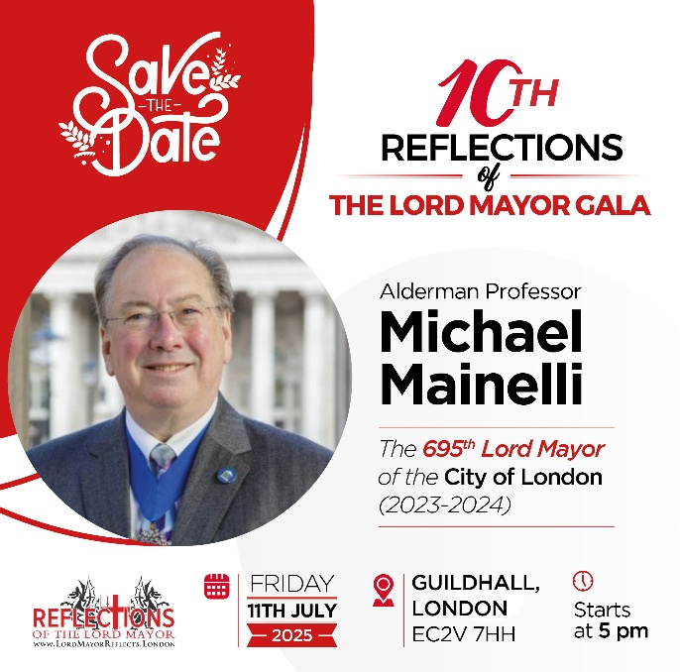  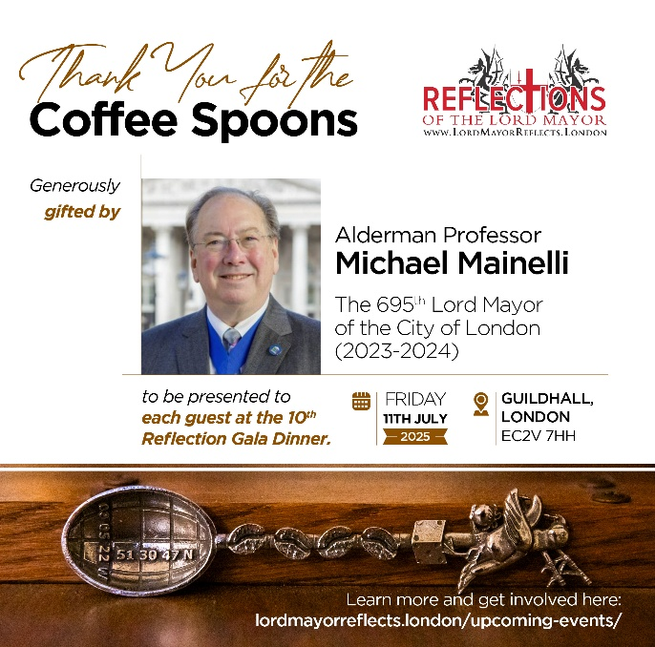

Chris Seow is arranging the next in his ever-popular "Reflections" galas in the magnificent surroundings of the Guildhall; this year the 695th Lord Mayor of the City of London Alderman Professor Michael Mainelli, reviews his year in office. Save the date, and sign up for updates at [https://lordmayorreflects.london/](https://broadstreetwardclub.us6.list-manage.com/track/click?u=d0e1ef8f8533d45174070465f&id=4e0ad7fcfc&e=ca643272ff)

**Friday 19th September: Sheriff’s Ball Guildhall**

Step into a world of glitz and glamour to join the Sheriffs of the City of London, Alderman Gregory Jones KC and David Chalk, for an unforgettable evening at the 1920s inspired Sheriffs’ Ball!

This fun evening of wining and dining includes a drinks reception in the atmospheric Crypts, three-course dinner with wine in the stunning Great Hall, the ever popular dancing and a fundraising auction.

Further details to follow soon. To reserve your place or to donate an auction prize, please email [events@thelordmayorsappeal.org](mailto:events@thelordmayorsappeal.org)

**Tuesday 23rd September 2024 - City Giving Day**

City Giving Day is a simple but impactful initiative that enables City companies and employees to celebrate and showcase their philanthropic and volunteering achievements and encourage others to get involved.

You can organise your own events or you could sign up to take part in one of the City Giving Day events organised by or on behalf of The Lord Mayor’s Appeal: see the Lord Mayor’s Appeal News and Events page or email [cgd@thelordmayorsappeal.org](mailto:cgd@thelordmayorsappeal.org)

**Wednesday 5th November 2025 -The Grand Finale**

The Lord Mayor and Lady Mayoress will be hosting their Grand Finale in aid of The Lord Mayor's Appeal.

Held in the truly spectacular setting of the Guildhall, in London, this fun and prestigious black-tie event will be a celebration of the mayoral year and the final fundraiser of the year.

The event for up to 450 guests will include a champagne reception, three course fine dining menu, silent and live auction and exciting entertainment.

Ticket prices and further event details to be announced in due course. In the meantime, to express an interest in attending please email [events@thelordmayorsappeal.org](mailto:events@thelordmayorsappeal.org)

**Notes on Completing Application Forms for Events**

|  |  |
| --- | --- |
| 1. | **Members should complete a separate online event application form for each event they wish to attend.**  <https://www.guild-freemen-london.co.uk/events>  If paper forms are required, they can be downloaded from the Guild’s website or obtained from the Guild Office. Members may apply for events online directly from the Guild’s website. |
| 2. | You are advised to apply before the **Ticket Allocation Date** (shown at the end of the description of each event in the Programme of Events), as this is the date on which bids will be reviewed and tickets allocated. Members are given priority for two tickets each.  *However, if you do wish to bring more than one guest, include them in your application and we will do our best to accommodate them.*  If an event is over-subscribed at the Ticket Allocation Date, a ballot will be held. Those who are successful (to the capacity for the function) will be sent more details about the event, and the rest placed on a Waiting List and notified accordingly.  Bids received after the Ticket Allocation Date will be allocated places in the order applications are received.  Places are often available right up to the event itself, so please do not hesitate to apply for tickets after the Ticket Allocation Date. The availability of places after the Ticket Allocation Date can be checked on the website or by contacting the Guild Office. |
| 3. | If you have any special requests or wish to add information to your booking, please use the Special Instructions box on the application page of the website or the form. |
| 4. | Please state clearly on each Application Form the Event Name, the Event Number and the Date of the Event that you wish to attend. |
| 5. | When recording on the Application Form the details of your guests, please note that the title “Mr”, “Mrs” “Ms” or “Miss” should be used unless there is an entitlement to another form of address. **The details you provide will be used in any list of guests that may be published and when applicable on place name cards.** Please also provide the first names of all guests and fill in the ‘gender’ column since, a title, e.g., Doctor or Captain, may conceal a person’s gender. |
| 6. | Everyone shown on an application form will **be seated together.** Please notify us on your application form if you would like to sit with someone who will be applying separately, we will endeavour to accommodate your wishes. |
| 7. | In the space on the application form for recording special **dietary requests**, please be specific about what cannot be eaten for each person. **Dietary requests made at an event, may incur additional charges which will be passed on to you.** |
| 8. | **If applying by post**: Please do not send cheques. We prefer payment by Bank Transfer or Direct Debit as each cheque now costs the Guild £1.50 to deposit. We will, of course, accept cheques if necessary and will ask for payment when we allocate your places.  **If applying online:** Requests for payment will be sent to successful applicants when the places are allocated. Payment may be made by Direct Debit, bank transfer or cheque (if necessary). Full instructions will be provided. |
| 9. | Application Forms should be sent to **The Guild of Freemen, Rooms 78/79, 65 London Wall, LONDON EC2M 5TU**. It is impossible to acknowledge the thousands of applications as a matter of routine, but if you wish us to acknowledge receipt for your applications, please provide an email address. Applications made via the website will be auto acknowledged. |
| 10. | If you wish to be sent a receipt for your payment for an event, please inform us when you send in your application form(s), and please enclose a stamped, self-addressed envelope. Receipts will not be sent out until your payment has been received. |
| 11. | Letters or emails giving **detailed arrangements for the event**, together with tickets or invitation cards where appropriate, will be sent out on or soon after the Ticket Allocation Date, i.e., about 4-6 weeks in advance of the event. The letter will show the latest cancellation date to be sure to obtain a refund. Most events will be allocated by email, but we will send a letter if we do not have your email address. Pour memoire cards for the Black-Tie Dinners and the Banquet will be sent by post. |
| 12. | Value Added Tax (Number 227 2551 75) is included in the cost of all events that take place in UK except those where the Guild lays on travel or overnight accommodation. No VAT is payable on overseas trips or donations to the Guild’s Charity. |
| 13. | Details of all events are correct at time of publication but are subject to change without notice. |

**If you have queries about an event, please do not hesitate to contact the Guild Office**

**BEFORE sending your application.**