# 

**The Guild of Freemen of the City of London**

*Patron*

**THE RIGHT HONOURABLE THE LORD MAYOR**

*The Clerk*

**Rooms 78/79**

**65 London Wall**

**London, EC2M 5TU**

**Tel: 020 7239 9016**

**email: clerk@guild-freemen-london.co.uk**

*Registered Address*

**4 DOWGATE HILL, LONDON EC4R 2SH**

*Company Number*

**00109150**

*A Company Limited by Guarantee*

**NEWSLETTER DECEMBER 2024**

Since the last newsletter, the Master has represented the Guild at a number of events.

She had the honour of planting a cross of Remembrance at the annual Livery Service of Remembrance arranged by the Livery committee, which was held in St Paul’s Garden and attended by nearly all Livery Masters.

The same week saw the new Lord Mayor, Alderman Alastair King DL take his position at the Silent Ceremony with his Lord Mayor’s Show taking place the following day.

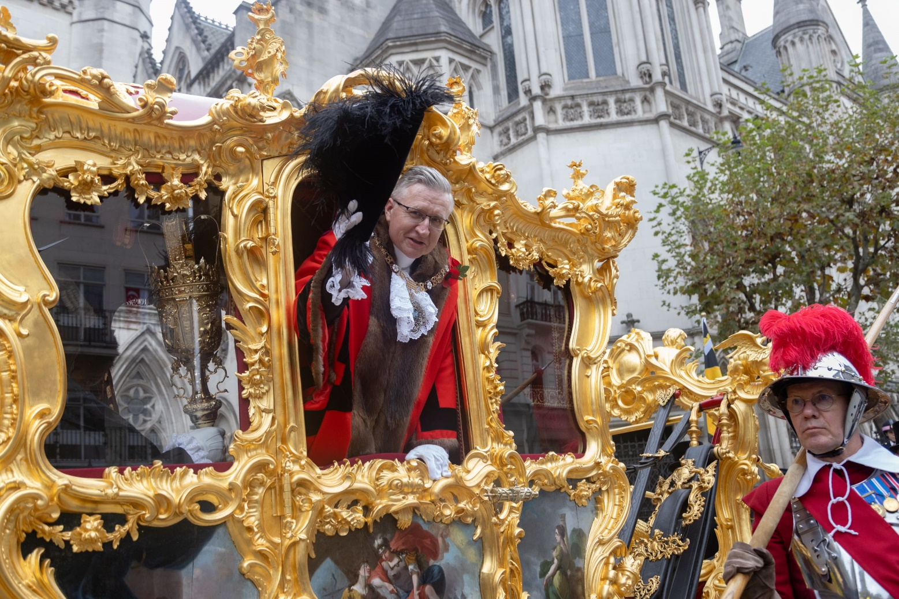

The Master shared a landau with the City Livery Club, the Royal Society of St George and the United Wards Club, all had personal escorts, the Guild’s being from our affiliated military unit, 253 Company RMP.

Waiting to take their place in the parade

|  |  |
| --- | --- |
| The Master with Alderman Professor Emma Edhem, President of the City Livery Club | Clifford Rust, Chairman, Royal Society of St George (City Branch) and Dhruv Patel OBE, President of the United Wards Club |

Guild members watched the Show from the streets close to Guildhall with a group enjoying a fine four course lunch in the members dining room.

Later in November Guild member Andrew Johnson gave a fascinating online talk on *Tea and Opium* and explained the part that both played in Anglo Chinese relationships, trade and the fierce battles that took place over both commodities, those conflicts being either out and out war, or the race to build vessels that could carry the tea the fastest to its destination.

This month we had the splendour of Guildhall and the Guilds’ Annual Banquet.

Archbishop Nikitas of Thyateira and Great Britain gave a moving Grace and we had speeches from the Senior Warden Adrian Waddingham CBE, the Master, and her speaker, Nigel Wray. Alderman Sir Andrew Parmley also spoke and the Guild was fortunate to have both Sheriffs attend. As usual the London Banqueting Ensemble entertained us splendidly during the meal with operatic tenor Yuri Sabatini bringing the evening to a close. The Master had also arranged for a magician to amuse and intrigue.

It was the Guild Beadle, John Hollingsworth’s last event and the Master presented John with a warrant of Life membership, a cheque (from members and Court donations) as well as a pair of Guild cufflinks. After over 36 years, we thank John for his diligent service and wish him well for the future. We look forward to seeing him at an event, when he is *off duty.*

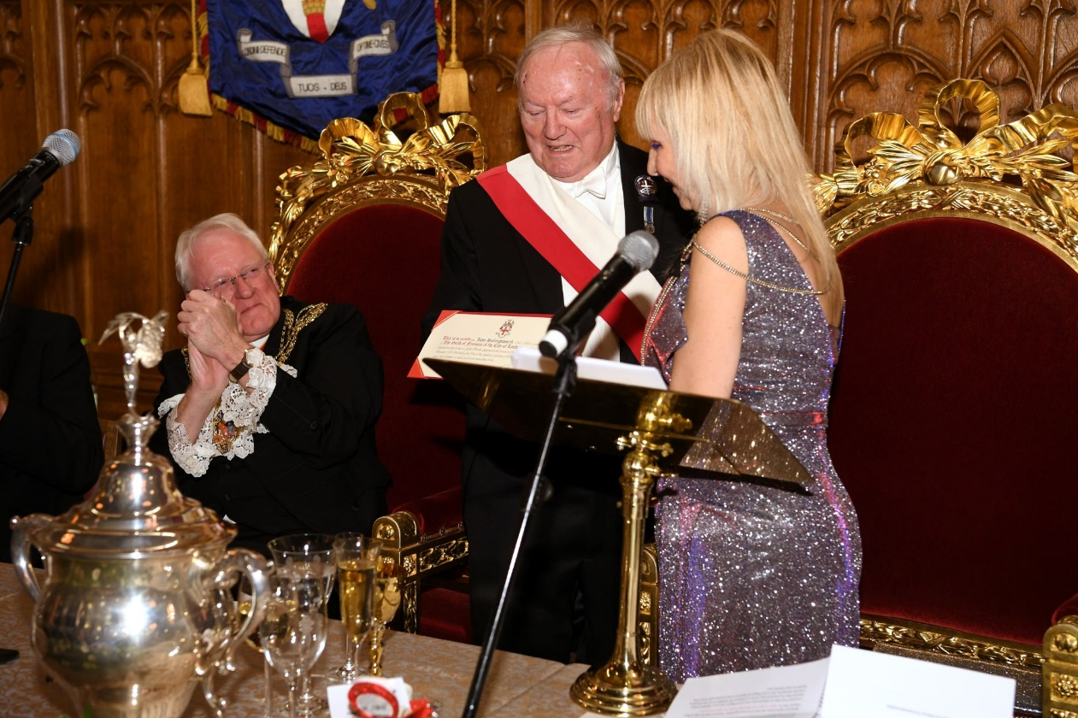

Beadle John, accepting gifts from the Master

|  |  |
| --- | --- |
|  |  |

|  |  |
| --- | --- |
|  |  |
|  |  |
|  |  |

On the Monday following the Banquet members gathered for the Guild Carol Service, conducted by the Revd. Stephen Baxter parish priest to St Stephen Walbrook though the Service took place at another Wren church, St Mary le Bow as St Stephen Walbrook is undergoing repairs. Our thanks go to the wonderful choir and organist and to the readers. Drinks and nibbles followed the Service.

|  |  |
| --- | --- |
|  |  |

**Looking ahead to 2025….**

The Master Elect’s first three events are now bookable on the website, beginning with his Installation on **Thursday 23rd January** followed by a black-tie dinner at Tallow Chandlers’ Hall. Members wishing to attend the Installation should arrive at Tallows’ at 6pm. Those only wishing to attend the dinner should arrive at Tallows at 6:30pm to join the pre-dinner drinks reception. Allocation letters and pour memoire cards will be sent in the New Year. To book use this link:

On **Tuesday 28th January** we have a private visit of the Great Hall at St Bartholomew’s which is Grade 1 listed and is the oldest hospital still operating on its original site. The Hall was once used as the meeting place of the Governors and medical students sat their exams in the Hall until the 1990’s. Since August 2024 a conservation project has been undertaken to protect and preserve the amazing ceiling, a masterpiece of Jean Baptiste St Michele, the famous portrait of Henry VII and the hospital’s patron Saint, Bartholomew and to upgrade the heating and other systems. The conservation project will not be completed until next summer, so this is the Guild opportunity to see *conservation in action.* For that reason, this visit is not for those will mobility issues and will involve wearing hard hats and climbing on scaffold blocks to view the ceiling.

The tour will begin at 4pm and last for roughly two hours, after which we will enjoy a two-course supper at a nearby pub. The cost of the visit and supper is £85 per person.

Then on **Tuesday 11th February** we meet at Côte on Ludgate Hill, near St Paul’s at 12 noon to enjoy a three-course lunch with wine, before taking a short walk to the St Bride Foundation. In the heart of this Grade II Victorian listed building is an exceptional and rare archive relating to all matters printing, publishing and graphic design. The cost of this tour and lunch is £85 per person.

We are still finalising details of some of the remainder of next year’s programme, but below are the known dates for your diaries and most, if not all the events will be bookable on the website by February (if not sooner).

Thursday 23rd January Installation of the new Master with dinner at Tallow Chandlers’ Hall

Tuesday 28th January Visit to the Great Hall, St Bartholomew’s and pub supper

Tuesday 11th February Lunch followed by a visit to St Brides Print room followed by lunch

Tuesday 25th February Tour of a private Jade collection followed by lunch in Chelsea

Thursday 6th March Visit to the College of Arms including a buffet supper at the College

Wednesday 26th March Black tie dinner at Barber Surgeons’ Hall

Friday 28th March United Guilds Service followed by lunch at Pewterers’ Hall

Sunday 6th- Holiday in Norfolk

Tuesday 8th April

Thursday 10th April The Lord Mayor’s Big Curry Lunch at Guildhall

Monday 28th April Informal tour of Battersea Power Station and walk nearby, led by the Master’s wife, Angela Waddingham, with tea and cake to conclude the afternoon.

Wednesday 7th May Guided visit of the Crick Museum and lunch

Wednesday 18th June Guided tour of Formans Smokehouse and lunch

Monday 30th June Black tie dinner at Haberdashers’ Hall

Saturday 19th July Cart Marking

Tuesday 29th July Holland Park Opera – La Traviata

Wednesday 10th September Royal Holloway visit (NB the change of date)

Sunday 28th September Sheep Drive and lunch

Sunday 28th September - Holiday in the Southern Lake District

Thursday 2nd October

Monday 27th October Black tie dinner at Trinity House

Saturday 8th November Lord Mayor’s Show and lunch at the Guildhall

Friday 5th December The Annual Banquet at Guildhall

Wednesday 10th December Carol Service at St Martin within Ludgate followed by a traditional Christmas lunch at Stationers’ Hall

Lunch at Mercers’ Hall, a guided tour of the Clock Museum, a celebration of Lancashire day with a quiz and fish ‘n’ chips, an outing to the Catering College, and more are also planned but dates have yet to be finalised.

**Other Guild News**

Sorry to begin on a sad note, but those who new Guild member David Hyde may wish to attend his funeral or send a message of condolence to his wife Jennifer. All details can be found at the link below:

<https://www.funeraldirector.co.uk/funeral/david-arthur-hyde/?funeral_status=2>

**The Guild is pleased to announce that we are back on Facebook!!!**

After a spell of dormancy on Facebook and a misplaced password (staff changes!), Guild member Paul Williams has created a new Facebook page with a very similar name. The previous page called *Guild of freemen of the city of London* is still online because without a password we cannot take it down however, the new page called **The Guild of Freemen of The City of London** is now up and running.

Currently there is one post covering the recent Guild Banquet. The *new* page will we updated regularly and would be very pleased if you would unlike the previous page and "Like" the new page.

When posting photographs on Facebook of Guild events that you attend it will help the popularity of the new page if you could tag the Guild by using "@The Guild Of Freemen of The City Of London" please.

As the admin team develops the new page, it will eventually include links to the website diary section to help with booking future events.

Guild Court Assistant and current Master Patternmaker, **Deputy Keith Bottomley** is standing for election as non-Aldermanic Sheriff. Keith would welcome support from any Guild member who is also a Liveryman, to sign up as a supporter use this [link:](https://keithbottomley.city/support-keith/)  To find out more about what Keith hopes to achieve if elected as Sheriff, use this [link:](https://keithbottomley.city/news/)

Central to Keith’s campaign are *opportunity for young people,* alongside the ‘*value of the rule of law*’ and ‘*diversity*’.

For many years the Guild has arranged and staffed a second handbook stall at the Red Cross Christmas Fair, last year led by the Master Elect, who will be too busy to take the lead and drive around London and its surrounds collecting book donations, **so we are looking for a volunteer**. No previous experience necessary, just a willingness to attend a few pre-Fair meetings so the organisation is tip-top and to drive around collecting book donations. Stalwart of the book stall and the Fair, Guild member Frances Golland will be on hand to advise and assist.

|  |  |
| --- | --- |
|  | ***If you have the desire to serve and support both the Guild and the Red Cross, please email the Clerk.***  ***The Fair will be held on Monday 8th and Tuesday 9th December*** |

Jennifer Andersen, wife of Guild Court Assistant and current Master World Trader, Lars Andersen has written a very interesting and useful Guide to the City and its traditions – too late for many now as a Christmas present (sorry Jennifer) however, it is well worth a read and it’s the sort of book you can dip in and out of and refer back to when you need a reminder.

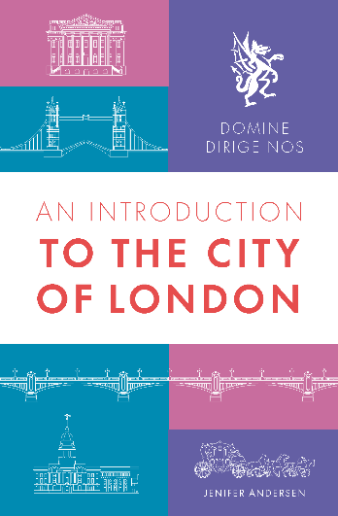

**Domine Dirige Nos**

**An Introduction to the City of London**

**by Jenifer Andersen**

with foreword by Sir William Russell, Lord Mayor 2019-2021

£15 + £3 P&P (£5 will be donated to the Lord Mayor’s Appeal)

To order in bulk contact the author: CityOfLondonBook@gmail.com

A unique introductory visual guide and essential reading for anyone with an interest in the City of London and its traditions. Learn at-a-glance about the history of the Square Mile, geography, wards, people, livery companies and a year in the life of civic London.

**HISTORY -** from Roman Londinium to the modern-day city

**GEOGRAPHY -** buildings, livery halls, churches, rivers and bridgesthat make up the Square Mile

**WARDS -** the subdivisions of the City and their unique system of voting

**PEOPLE** – who does what in the City,the colourful civic processions and how to spot the personalities

**LIVERY COMPANIES -** the history, Order of Precedence, groupings, Common Hall, fashion and traditions

**CITY DIARIES -** a year in the life of the civic city

Available at: Daunts Books, 61 Cheapside, EC2V 6AX

OR Email the author at [CityOfLondonBook@gmail.com](mailto:CityOfLondonBook@gmail.com) with your name, delivery address and number of copies required. A payment link will be emailed

OR On Etsy <https://www.etsy.com/uk/listing/973414582/an-introduction-to-the-city-of-london>

***It feels as if it was only a couple of months ago that I was writing to wish you a healthy and happy 2024, the year has simply flown by with the many enjoyable events, now it’s time for me to focus on family and some rest to ensure that 2025 is as enjoyable as the past year.***

***The office is closed from Monday 23rd December, reopening on Monday 6th January, so Abbie and I wish you all a very happy Christmas.***

***Kate***

